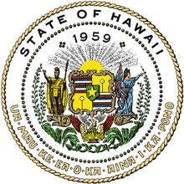

DEPARTMENT OF LAND AND NATURAL RESOURCES

DAVID Y. IGE
GOVERNOR

SUZANNE D. CASE
CHAIRPERSON

FOR IMMEDIATE RELEASE
March 13, 2020

MO‘OMOMI CBFSA HEARINGS POSTPONED

Due to social distancing recommendations associated with COVID-19 previously scheduled public hearings on the Mo‘omomi Community-Based Subsistence Fishing Area (CBFSA) have been postponed. DLNR will publicize rescheduling of these statewide meetings at a later date.
# # #

Media Contact:
Dan Dennison
Senior Communications Manager
(808) 587-0396
Dlnr.comms@hawaii.gov

